In order to understand the data

1. Central tendency

* Mean
* Median
* Mode
* Difference between mean and median
* Skewed distributions
* Pos/neg/no

All maths developed by assuming data follows normal distribution

Mean= median =mode

Generally data never follows normal distribution

Transformation techniques

We need to learn outlier analysis

Data skew will happen bcz of outliers

1. Data dispersion

* Range
* Mean deviation
* Absolute mean deviation
* Variance
* Standard deviation

1. Range:

1,2,3,4,5,6,…..,100

Which point to which point, the data is distributed

Lower value=1

Upper value =100

Range= U.V-L.v= 100-1= 99

1 ------- 2 ----------- 3 --------- 4

4-1= 3

Drawback:

* Range never consider middle value
* It will consider only lower and upper values

1. Mean deviation:

How much Each every data point is deviated from mean point

$x_{1}=1,x_{2}=2,x_{3}=3,x_{4}=4,x_{5}=5$

Calculate the mean $\underline{x}=\frac{x_{1}+x_{2}+x_{3}+x_{4}+x_{5}}{5}$

$\underline{x}=\frac{1+2+3+4+5}{5}=3$

* Mean deviations from x1 : $\underline{x}-x_{1}=3-1=2$

X1 is deviated by 2 units from mean of the data

* Mean deviations from x2 : $\underline{x}-x_{2}=3-2=1$

X1 is deviated by 2 units from mean of the data

* Mean deviations from x3 : $\underline{x}-x_{3}=3-3=0$

X1 is deviated by 2 units from mean of the data

* Mean deviations from x4 : $\underline{x}-x_{4}=3-4=-1$

X1 is deviated by 2 units from mean of the data

* Mean deviations from x5 : $\underline{x}-x_{5}=3-5=-2$

X1 is deviated by 2 units from mean of the data

Total deviation of 5 observations

($\underline{x}-x_{1})+(\underline{x}-x_{2})+(\underline{x}-x_{3})+(\underline{x}-x_{4})+(\underline{x}-x_{5})$

Total deviation of n observations

($\underline{x}-x_{1})+(\underline{x}-x_{2})+(\underline{x}-x_{3})+…+(\underline{x}-x_{n})$

($\underline{x}-x_{1})+(\underline{x}-x_{2})+(\underline{x}-x_{3})+…+(\underline{x}-x_{n})=\sum_{i=1}^{n}{}(\underline{x}-x_{i})$

$Mean deviation=\sum_{i=1}^{n}{}(\underline{x}-x_{i})$

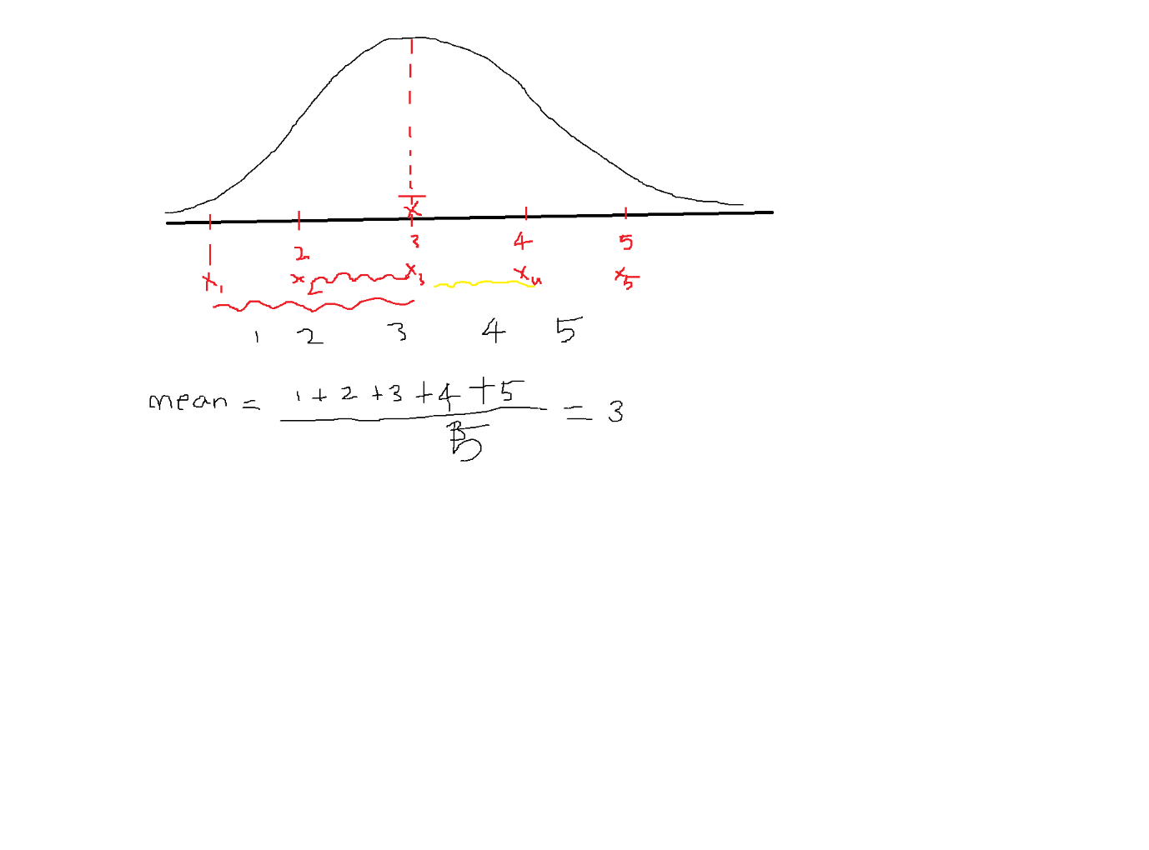

Draw back:

For the total 5 observations

The total mean deviation=

($\underline{x}-x_{1})+(\underline{x}-x_{2})+(\underline{x}-x_{3})+(\underline{x}-x_{4})+(\underline{x}-x_{5})=2+1+0-1-2=0$

We are seeing the deviation w.r.t each point

But the total deviation says : There is no deviation

Hence math fail

Yes =1 No=0----------- > 1-0=1

No =0 Yes=1 -------- > 0-1=-1

Yes =1 No=0 -------- > 1-0=1

No =0 Yes=1 ------- > 0-1 =-1

Total error = 1-1+1-1=0

This is a great ====== it is working and understanding each and every data point

Why it is happens zero ===== > positive and negative cancellations

+2 ====== > 2 points ahead from mean

-2 ====== > 2 points below from mean

I=-5Amp

How to avoid + and –

Which concept in maths will convert – to +

1. Mod /absolute values
2. Multiply *
3. Square
4. Absolute mean deviation:

* Absolute Mean deviations from x1 : $|\underline{x}-x_{1|}=|3-1|=2$

X1 is deviated by 2 units from mean of the data

* Absolute Mean deviations from x2 : $|\underline{x}-x_{2}|=|3-2|=1$

X2 is deviated by 2 units from mean of the data

* Absolute Mean deviations from x3 : $|\underline{x}-x_{3|}=|3-3|=0$

X3 is deviated by 2 units from mean of the data

* Absolute Mean deviations from x4 : |

X4 is deviated by 2 units from mean of the data

* Absolute Mean deviations from x5 : $\underline{|x}-x_{5|}=\left|3-5\right|=\left|-2\right|=2$

X5 is deviated by 2 units from mean of the data

Total deviation of 5 observations

|

Total deviation of n observations

|

|

Draw back:

| x | Y=|x| |
| --- | --- |
| -3 | 3 |
| -2 | 2 |
| -1 | 1 |
| 0 | 0 |
| 1 | 1 |
| 2 | 2 |
| 3 | 3 |

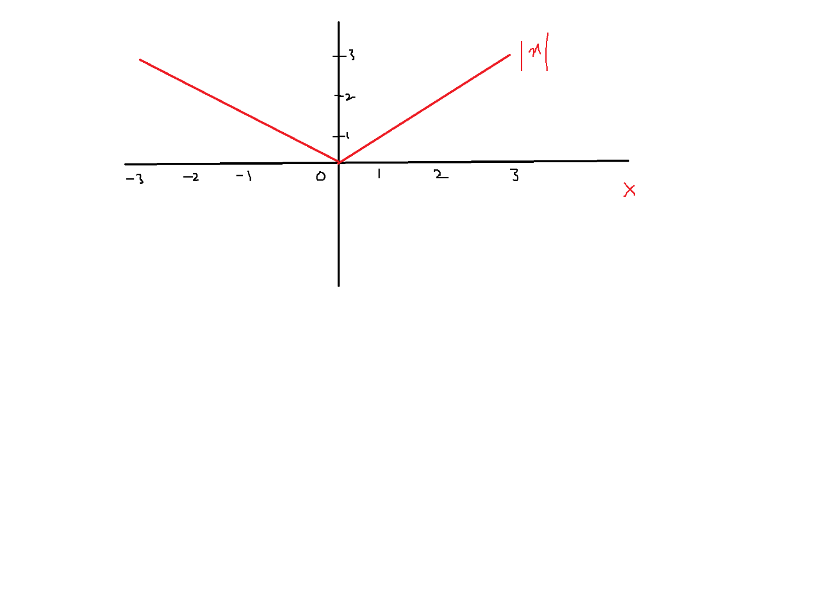

|x| graph is discontinue at point zero

Whenever any equation discontinue at some point

Then

Differentiation is not possible

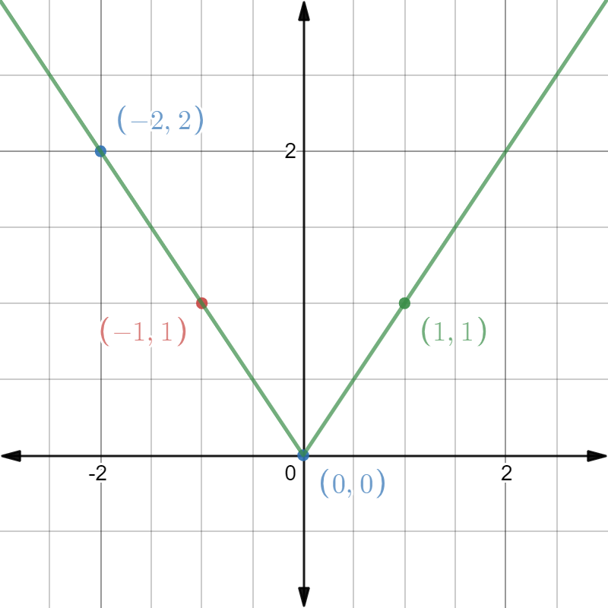

What is |x| differentiation=

d(|x|)/dx = x/|x|,

at x=0 ======= > 0/0 ========= >

indeterminant form

math fail

* Mean deviation gives total deviation as zero
* To avoid that we taken absolute value
* Absolute value giving total deviation
* The graph of |x| is a V-shape
* It is discontinue at point zero
* Anything discontinue at zero , some math concepts fail
* Differentiations and integration will not work
* |x| differentiation = x/|x|
* Keep x=0 ------ > 0/0 ----- indeterminant form
* To +

One option ======== > absolute

Another option = square

-1*-1= 1

1. Variance:

$(\underline{x}-x_{1 )^2 }={\left(3-1\right)}^{2}=4$

${\left(\underline{x}-x_{2}\right)}^{2}={\left(3-2\right)}^{2}=1$

${\left(\underline{x}-x_{3}\right)}^{2}={\left(3-3\right)}^{2}=0$

${\left(\underline{x}-x_{4}\right)}^{2}={\left(3-4\right)}^{2}=1$

${\left(\underline{x}-x_{5}\right)}^{2}={\left(3-5\right)}^{2}=4$

Total deviation of n observations

($\underline{x}-x_{1})^2+\underline{(x}-x_{2})^2+(\underline{x}-x_{3})^2+…+(\underline{x}-x_{n})^2$

$Variance=\sum_{i=1}^{n}{}{\left(\underline{x}-x_{i}\right)}^{2}$

Draw back:

| x | Y=x^2 |
| --- | --- |
| -3 | 9 |
| -2 | 4 |
| -1 | 1 |
| 0 | 1 |
| 2 | 4 |
| 3 | 9 |
|  |  |

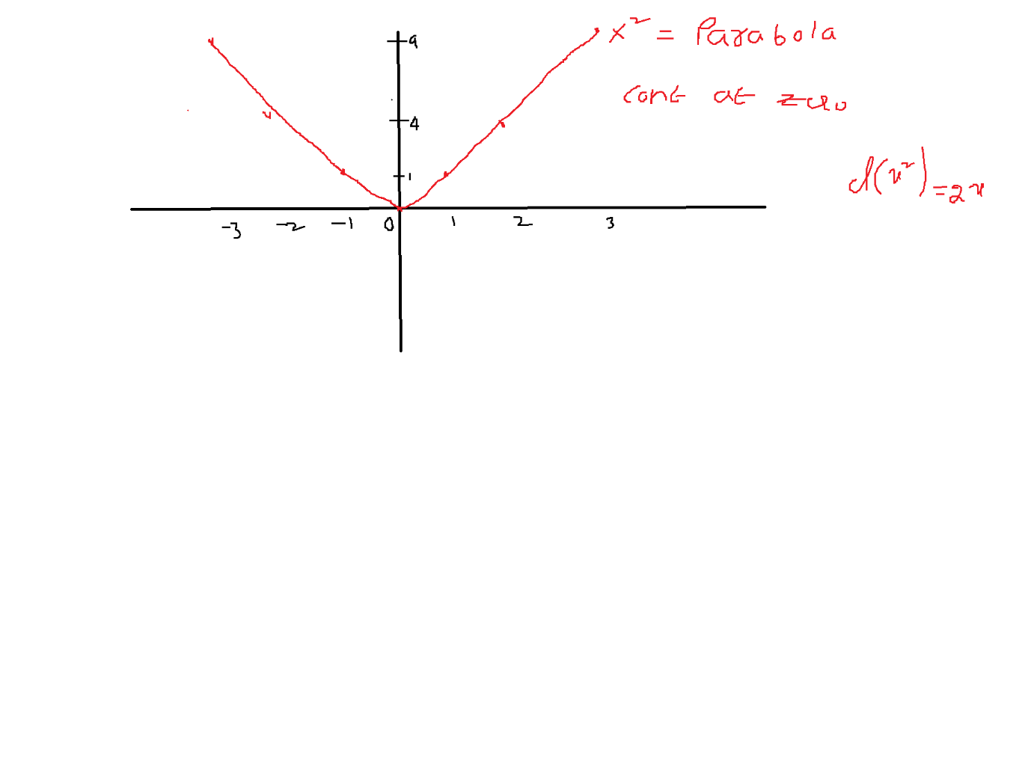

* The values will be rise , because of squaring

Km fare

1km 5rs ========== > (1km-3km)^2= -2km^2=4km^2

2km 10rs

3km 20rs

4km 30rs

5km 40rs

1+2+3+4+5/5=3km

Not only values units also rise

Km^2 =========== km?

Square root (km^2) ====== km

1. Standard deviation

$standard deviation=\sqrt{variance}$

$standard deviation=\sqrt{\sum_{i=1}^{n}{}{\left(\underline{x}-x_{i}\right)}^{2}}$

$standard deviation=σ$

$σ=\sqrt{variance}$

1. Range: H-L

$Mean deviation=\frac{1}{n}* \sum_{i=1}^{n}{}(\underline{x}-x_{i})$

$Absolute Mean deviation=\frac{1}{n}* \sum_{i=1}^{n}{}|\underline{x}-x_{i}|$

$Variance=\frac{1}{n}* \sum_{i=1}^{n}{}{\left(\underline{x}-x_{i}\right)}^{2}$

$standard deviation=\sqrt{var}=\sqrt{\frac{1}{n}* \sum_{i=1}^{n}{}{\left(\underline{x}-x_{i}\right)}^{2}}$